**TRAFFIC ROUTE PREDICTION**

**UJWALA DAMA**

**SRI MANVITHA MALAMPATI**

**SHREELAASYA VEJANDLA**

**NAVYASRI YARRAMREDDY**

1. **PLANNING AND RESEARCH**

**Scope of the project:**

Traffic congestion affects the country’s economy directly or indirectly by its means. Traffic congestion also takes people’s valuable time, cost of fuel every single day. As traffic congestion is a major problem for all classes in society, there has to be a small-scale traffic prediction for the people’s sake of living their lives without frustration or tension. For ensuring the country’s economic growth, the road user’s ease is required in the first place. This is possible only when the traffic flow is smooth. To deal with this, Traffic prediction is needed so that we can estimate or predict the future traffic to some extent. Many big cities experience traffic problems, particularly during some of the busier times of the day. It may be possible to take action to ease traffic on some roads if popular and alternative routes are continuously checked for traffic. There are many uses and benefits for real-time traffic simulation and prediction.

**Resources it will require**

**Software Requirements**

* Python IDLE ( 3.7.0)
* Node Js
* Visual Studio Community Version

**Back-end Languages**

* Python
* Java Script
* Solidity

**FrameWork**

* Flask

**Hardware Requirements**

* Processor : i5 and above
* RAM : 8GB and above
* ROM : 20GB and above

**2. FEASIBILITY STUDY**

**Feasibility Study**

A feasibility study evaluates a project's or system's practicality. As part of a feasibility study, the objective and rational analysis of a potential business or venture is conducted to determine its strengths and weaknesses, potential opportunities and threats, resources required to carry out, and ultimate success prospects. Two criteria should be considered when judging feasibility: the required cost and expected value.

**Types Of Feasibility Study**

A feasibility analysis evaluates the project’s potential for success; therefore, perceived objectivity is an essential factor in the credibility of the study for potential investors and lending institutions. There are five types of feasibility study—separate areas that a feasibility study examines, described below.

**1. Technical Feasibility**

This assessment focuses on the technical resources available to the organization. It helps organizations determine whether the technical resources meet capacity and whether the technical team is capable of converting the ideas into working systems. Technical feasibility also involves the evaluation of the hardware, software, and other technical requirements of the proposed system. As an exaggerated example, an organization wouldn’t want to try to put Star Trek’s transporters in their building—currently, this project is not technically feasible.

**2. Economic Feasibility**

This assessment typically involves a cost/ benefits analysis of the project, helping organizations determine the viability, cost, and benefits associated with a project before financial resources are allocated. It also serves as an independent [project assessment](https://www.simplilearn.com/risk-assessment-project-management-article) and enhances project credibility—helping decision-makers determine the positive economic benefits to the organization that the proposed project will provide.

### **3. Legal Feasibility**

This assessment investigates whether any aspect of the proposed project conflicts with legal requirements like zoning laws,[data protection](https://www.simplilearn.com/understanding-data-security-rar30-article) acts or social media laws. Let’s say an organization wants to construct a new office building in a specific location. A feasibility study might reveal the organization’s ideal location isn’t zoned for that type of business. That organization has just saved considerable time and effort by learning that their project was not feasible right from the beginning.

### **4. Operational Feasibility**

This assessment involves undertaking a study to analyze and determine whether—and how well—the organization’s needs can be met by completing the project. Operational feasibility studies also examine how a [project plan](https://www.simplilearn.com/project-management-plans-in-project-environment-rar79-article) satisfies the requirements identified in the requirements analysis phase of system development.

### **5. Scheduling Feasibility**

This assessment is the most important for [project success](https://www.simplilearn.com/how-to-make-a-project-successful-article); after all, a project will fail if not completed on time. In scheduling feasibility, an organization estimates how much time the project will take to complete.

When these areas have all been examined, the feasibility analysis helps identify any constraints the proposed project may face, including:

* Internal Project Constraints: Technical, Technology, Budget, Resource, etc.
* Internal Corporate Constraints: Financial, Marketing, Export, etc.
* External Constraints: Logistics, Environment, Laws, and Regulations, etc.

**3: DESIGN AND PROTOTYPING**

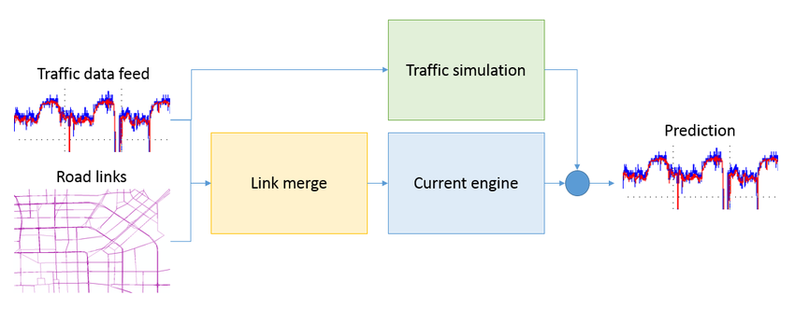

**Architecture diagram**

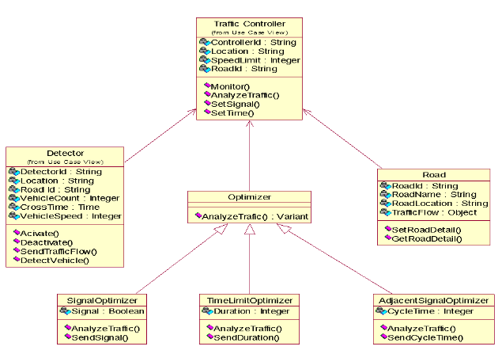

**Class diagram**

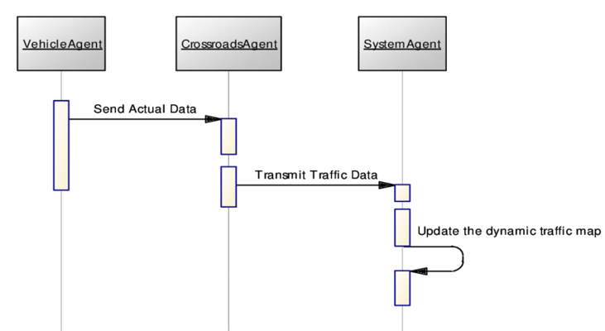

**Sequence diagram**

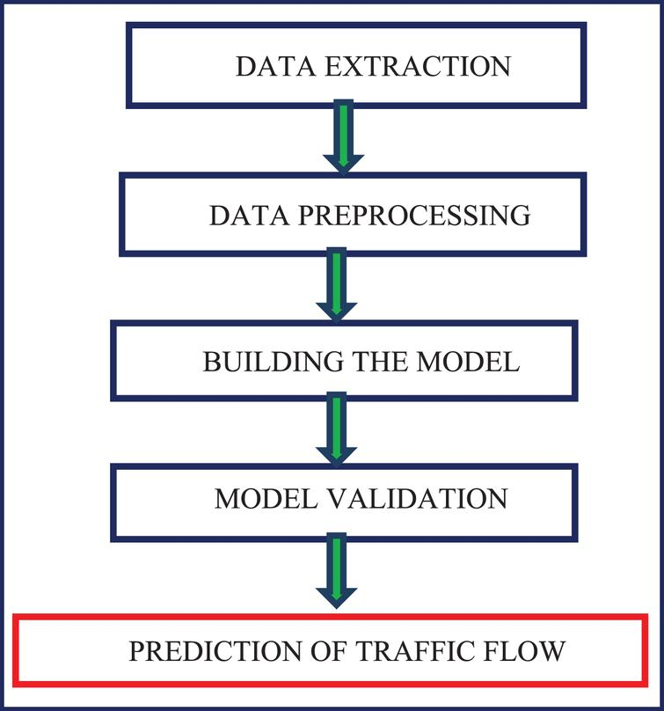

**Dataflow diagram**

**4. DEVELOPMENT**

In this project based on traffic congestion we are predicting alternate route for the passengers, to predict route we are training various machine learning algorithms such as SVM, Decision Tree and Random Forest and each algorithm performance is evaluated in terms of accuracy, precision, recall, FSCORE and confusion matrix graph. Before applying ML algorithms we have performed data analysis via graph visualization to understand traffic flow and congestion in different routes and after analysis we have employed ML algorithms for route prediction. Among all algorithms SVM performing worst and Decision Tree perform well.

**Algorithms:**

* **SVM :**
* Support Vector Machine (SVM) is a powerful machine learning algorithm used for linear or nonlinear classification, regression, and even outlier detection tasks. SVM algorithm is used for both classification and regression tasks. It finds an optimal hyperplane to separate data points of different classes in a high-dimensional space
* **Decision Tree :**
* Decision trees are a type of machine-learning algorithm that can be used for both classification and regression tasks. They work by learning simple decision rules inferred from the data features. These rules can then be used to predict the value of the target variable for new data samples. Decision trees are represented as tree structures, where each internal node represents a feature, each branch represents a decision rule, and each leaf node represents a prediction.
* **Random Forest :**
* Random forests or random decision forests is an ensemble learning method for classification, regression and other tasks that operates by constructing a multitude of decision trees at training time. For classification tasks, the output of the random forest is the class selected by most trees. For regression tasks, the mean or average prediction of the individual trees is returned.

**DATASET:**

To train all algorithms we have utilized traffic congestion dataset which can be downloaded from below KAGGLE URL

<https://www.kaggle.com/competitions/tabular-playground-series-mar-2022/data?select=train.csv>

In below screen we are displaying dataset details

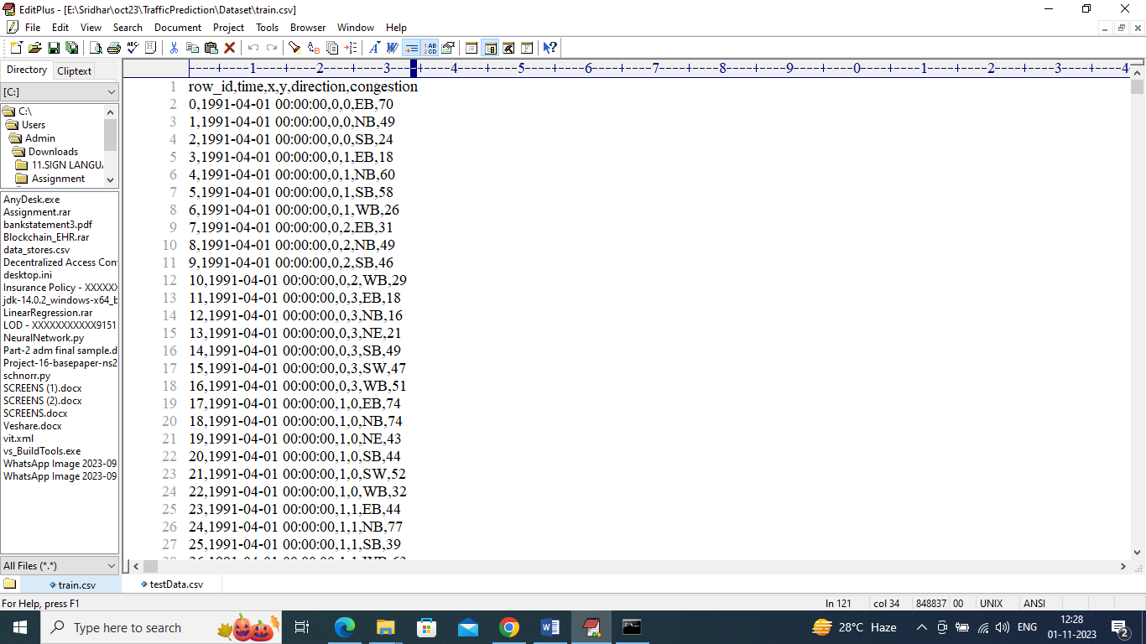

In above dataset we have Date, X and Y as latitude and longitude and then direction and then last column contains traffic congestion and by using this module we will train all ML algorithms. After training we will employ test data to predict alternate direction and below is the TEST data.



In above test data we have Date, X and Y location and traffic congestion but direction or route column is not available and this direction will be predicted by ML algorithm.

**5. OUTCOMES**

SCREEN SHOTS

We have coded this project using JUPYTER notebook and below are the code and output screens with blue color comments

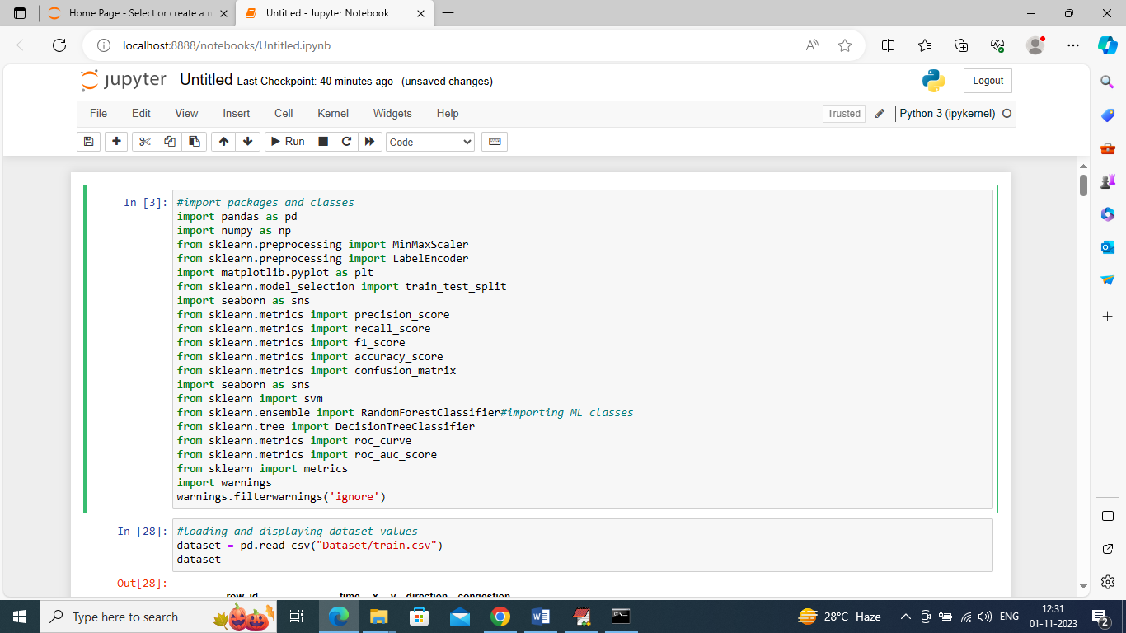

In above screen we are importing require python classes and packages

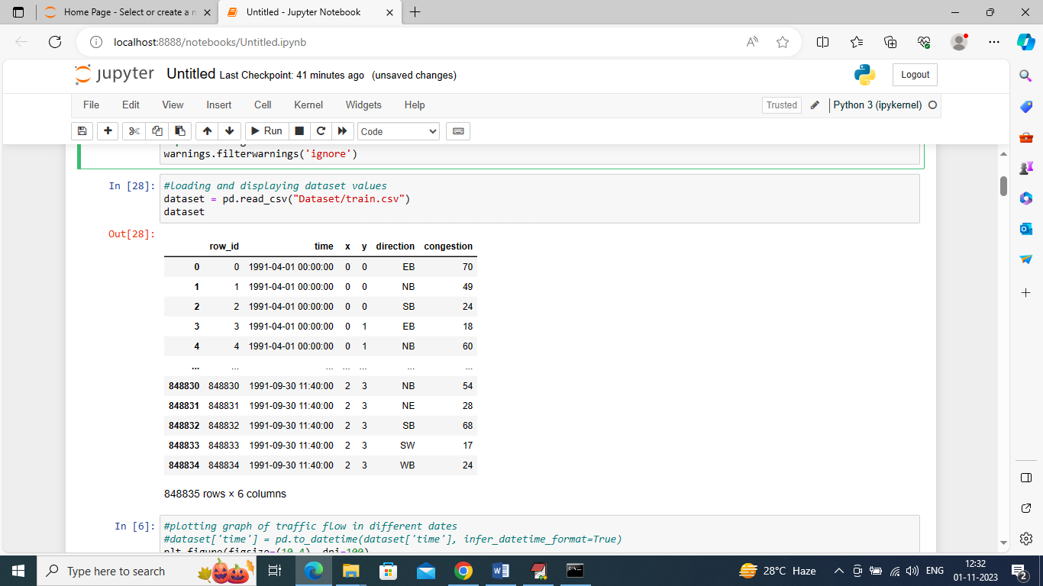

In above screen loading and displaying dataset values

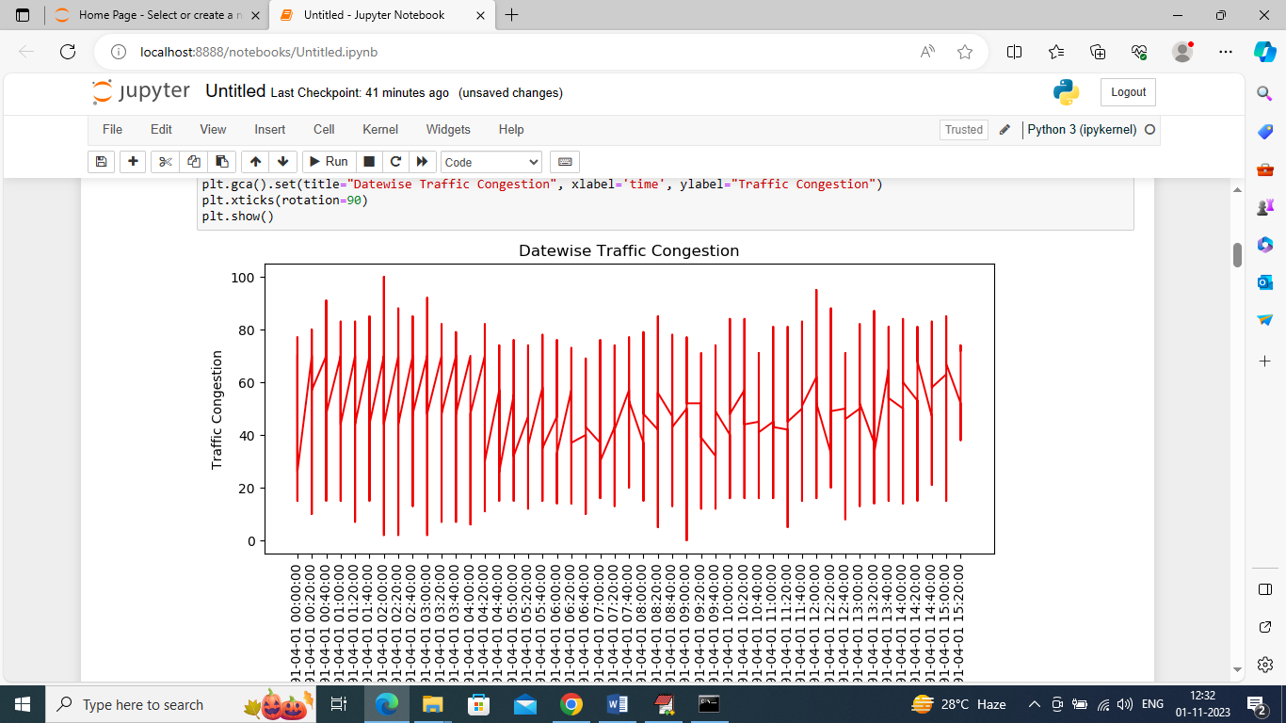

In above graph displaying traffic congestion on different dates where x-axis represents Date and y-axis represents traffic congestion

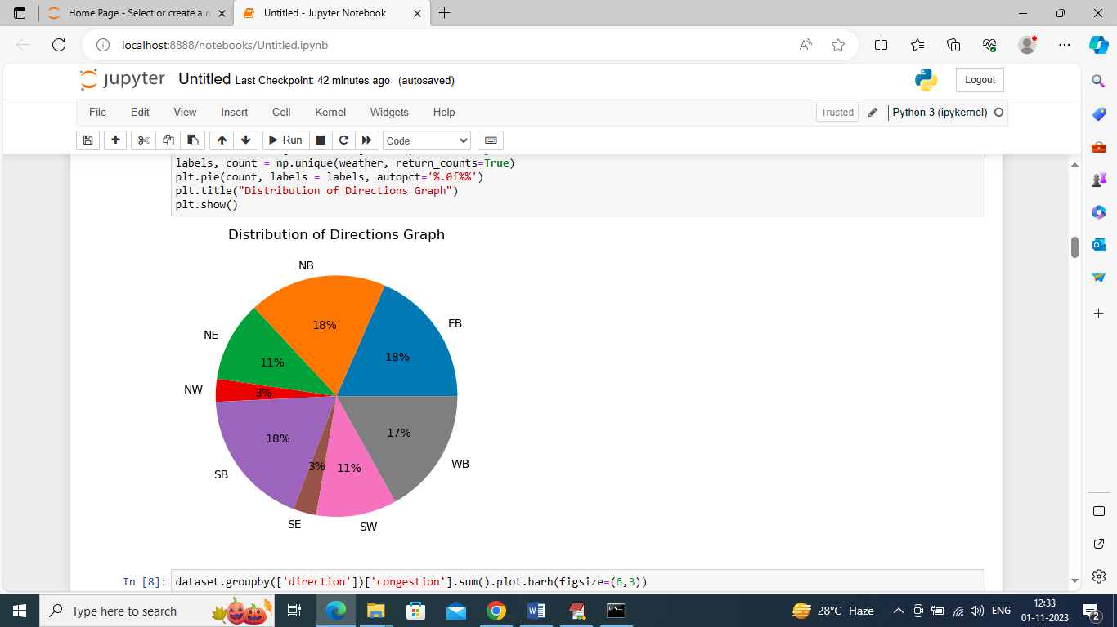

In above graph we are finding percentage of different directions or route exists in the dataset

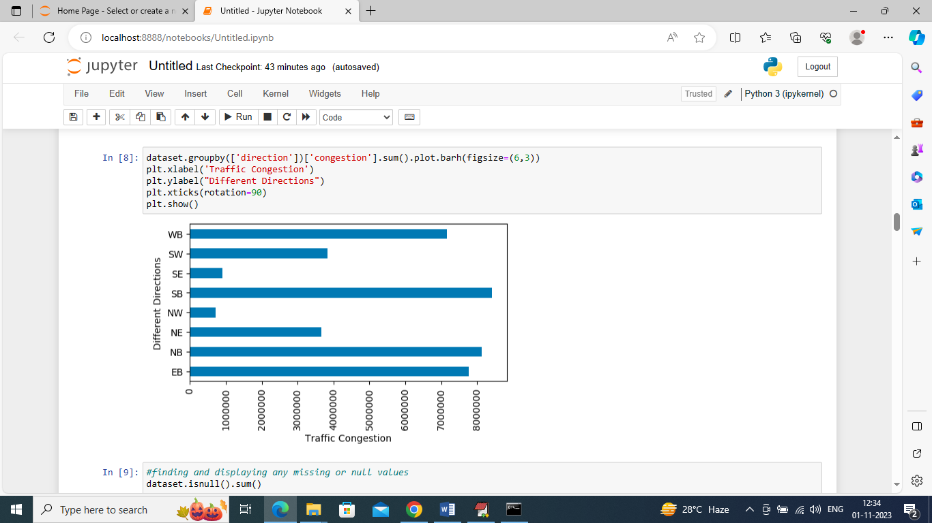

In above graph we are finding sum of traffic exists in each direction where x-axis represents traffic count and y-axis represents direction

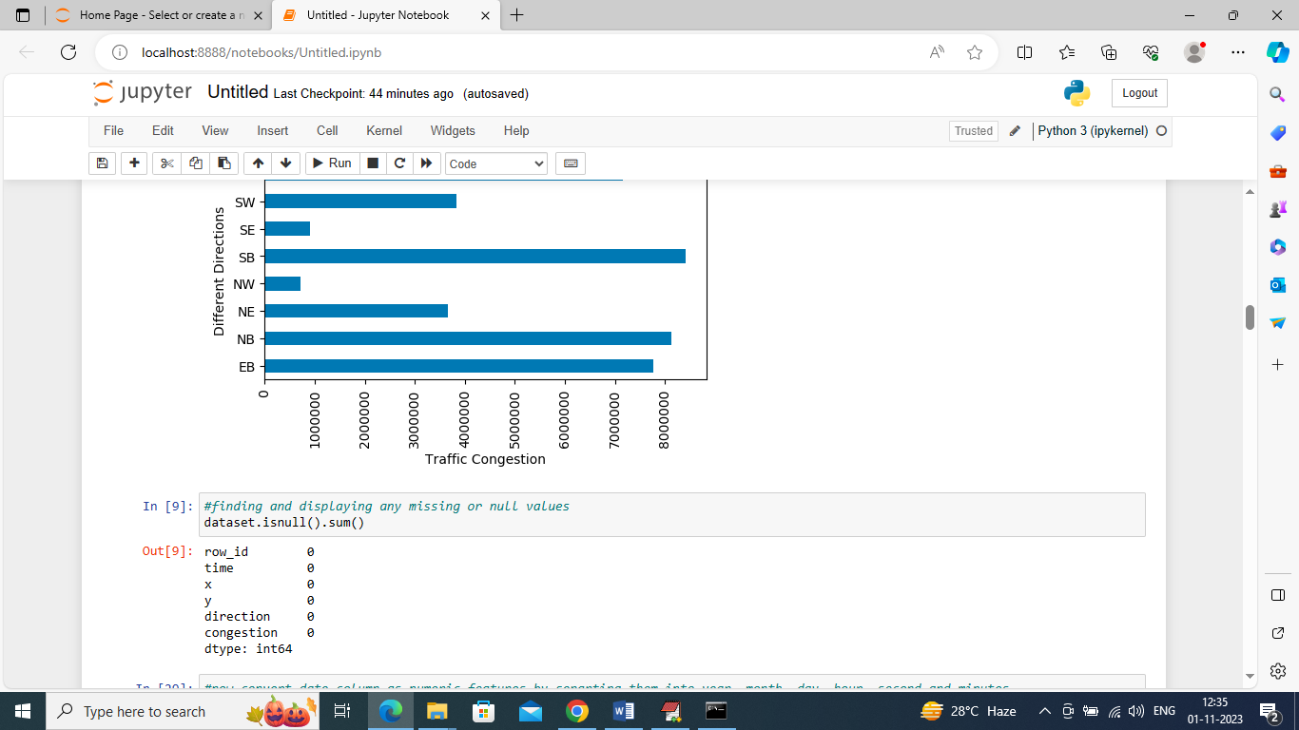

In above screen we are finding weather dataset contains any missing or null values but this dataset has no missing values

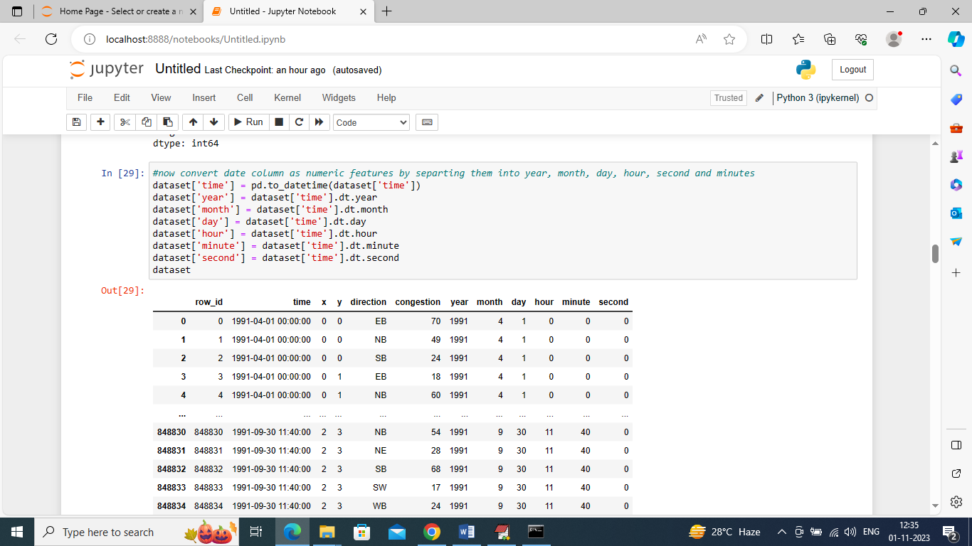

In above screen we are processing dataset to convert date into Day, Month and Year format so we can analyze traffic day or month wise and in above output we can see now dataset has day, year and month columns

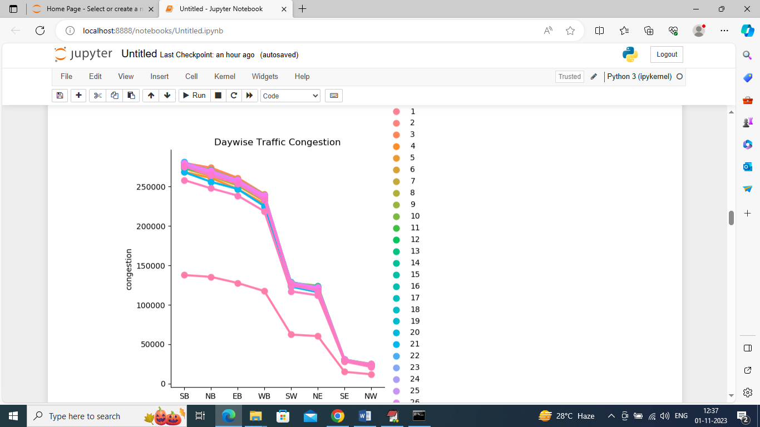

In above graph we are finding traffic day wise and each different color line represents different days traffic where x-axis is the direction and y-axis is the traffic congestion count

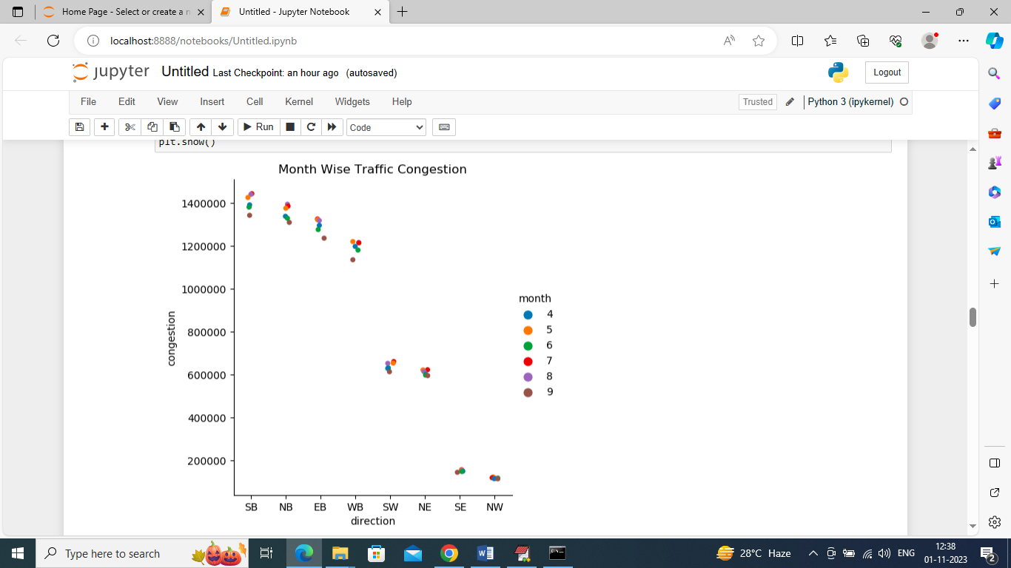

In above graph we are finding month wise traffic in different directions where x-axis represents direction and y-axis represents traffic congestion and different color dots represents months.

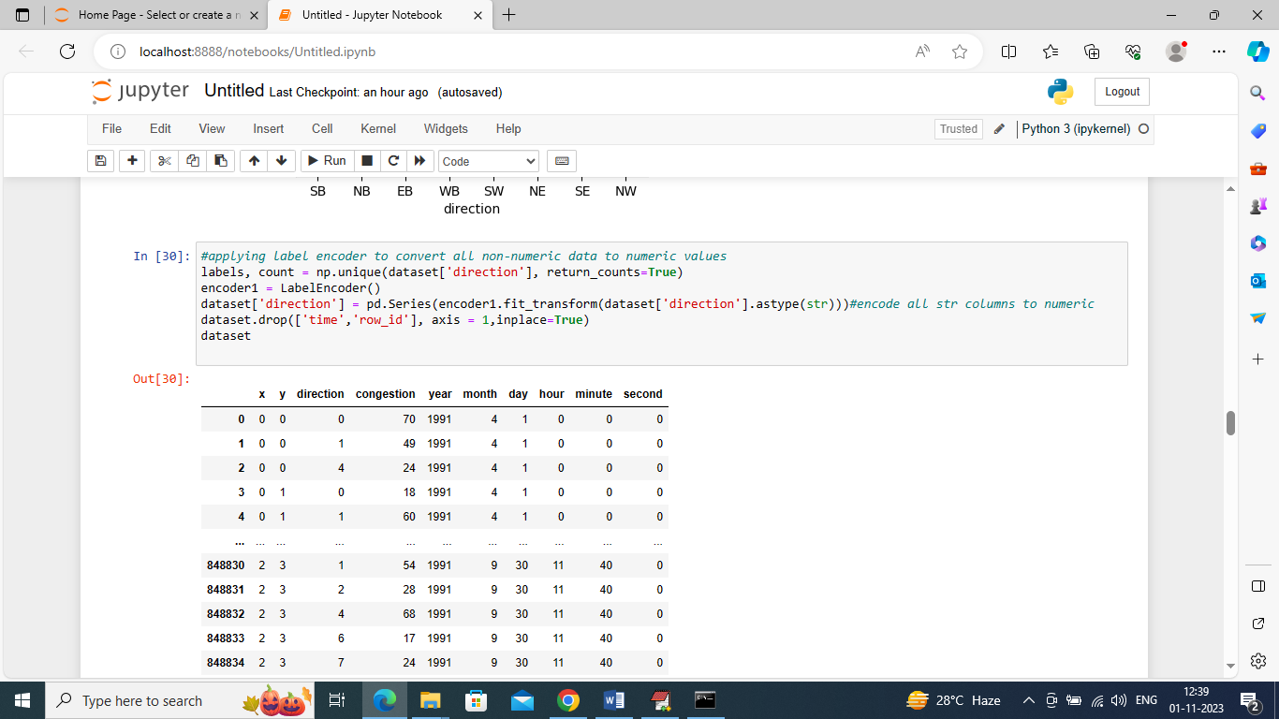

In above screen different directions are in string format so we have converted them into numeric format as ML will take all labels are numeric format so we have converted them into numeric labels

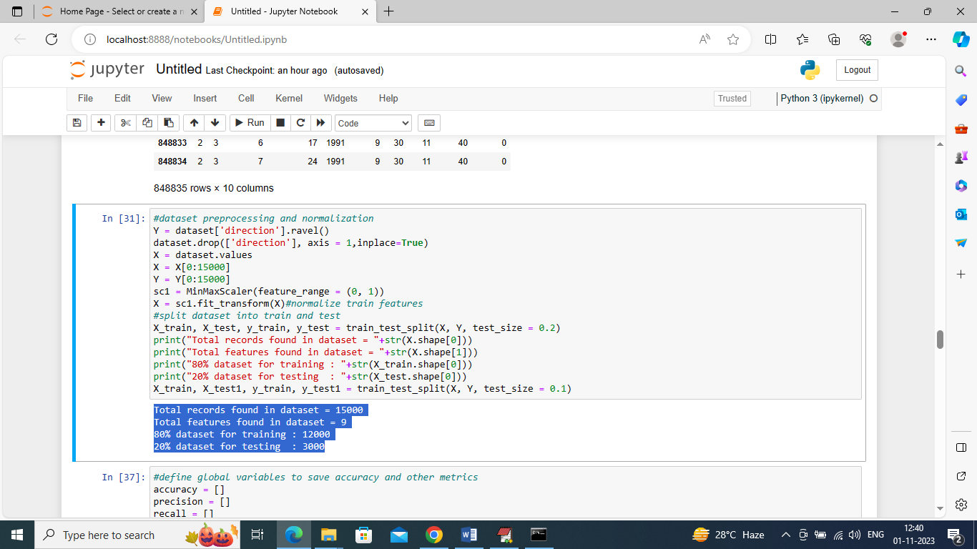

In above screen we are processing dataset such as normalization and then splitting into train and test where application using 80% dataset for training and 20% for testing and in blue color we can see train and test size

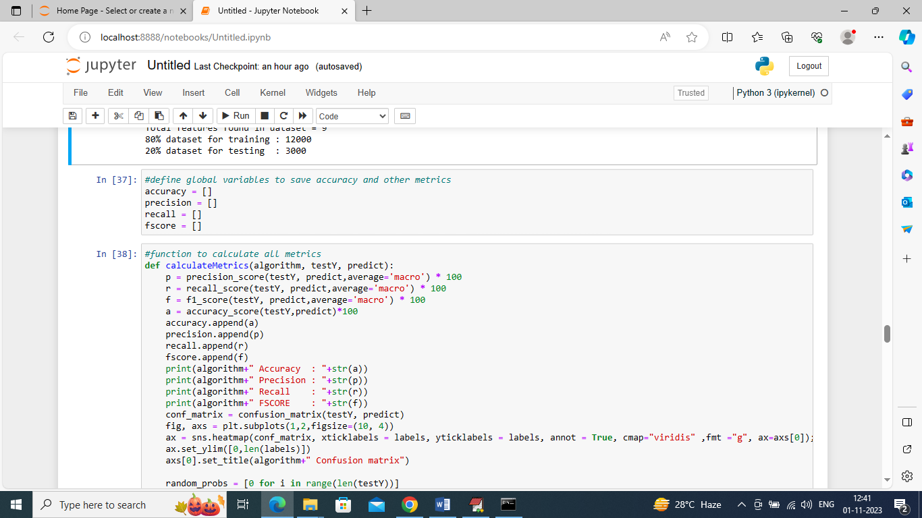

In above screen defining function to calculate accuracy and other metrics

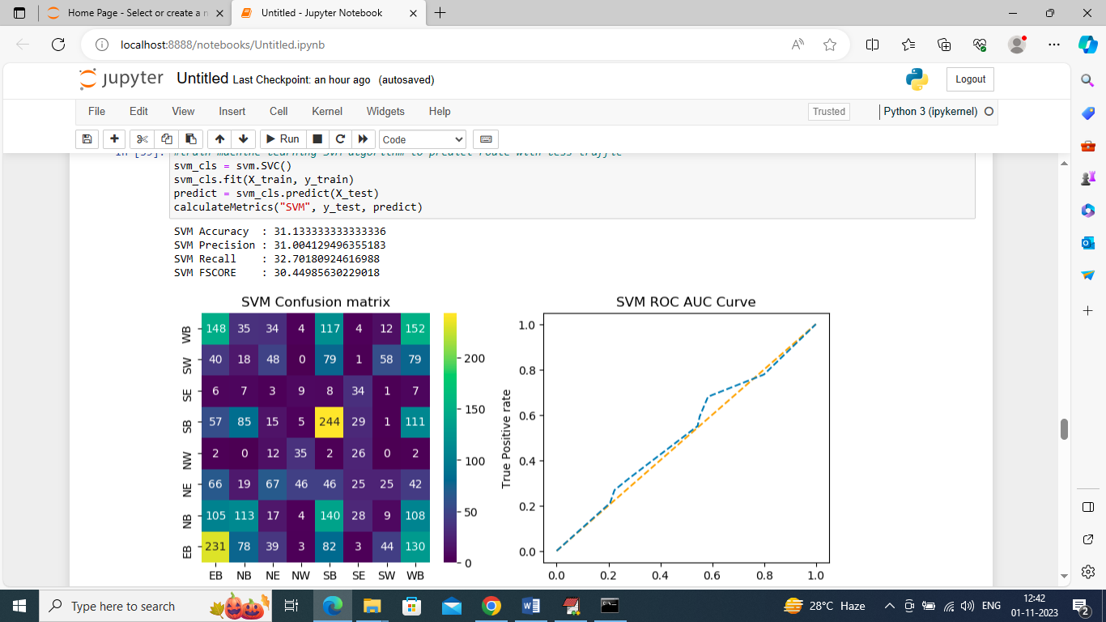

In above screen training SVM algorithm and after training SVM got 30% accuracy and can see other metrics also. In confusion matrix graph x-axis represents Predicted Labels and y-axis represents True Labels and all boxes in diagnol represents correct prediction count and remaining boxes represents incorrect prediction counts and from above graph we can notice SVM predicted many records incorrectly. In ROC curve graph x-axis represents False Prediction and y-axis represents True Predictions and if blue line comes on top of orange line then predictions are correct and if goes below orange line then predictions are incorrect and in above graph we can see only few predictions are correct

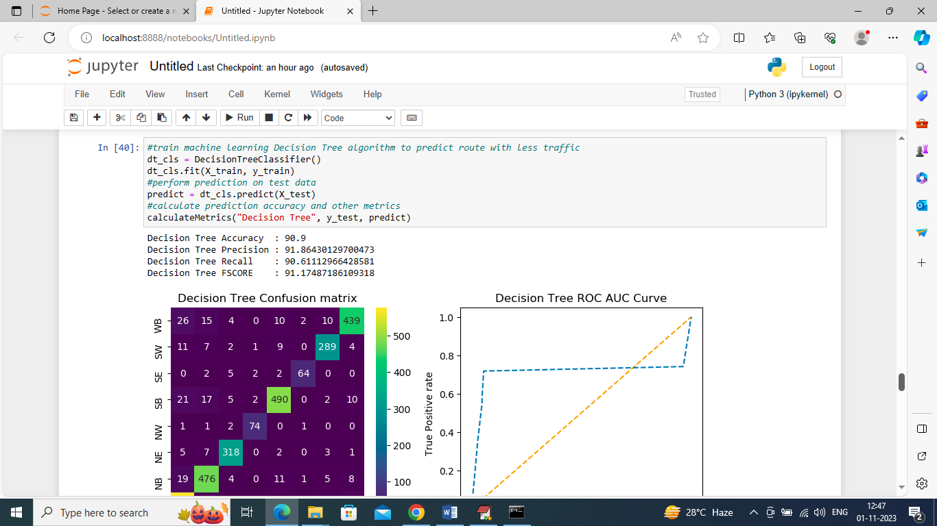

In above sceen training decision tree and it got 90.9% accuracy and can see other metrics and results graph

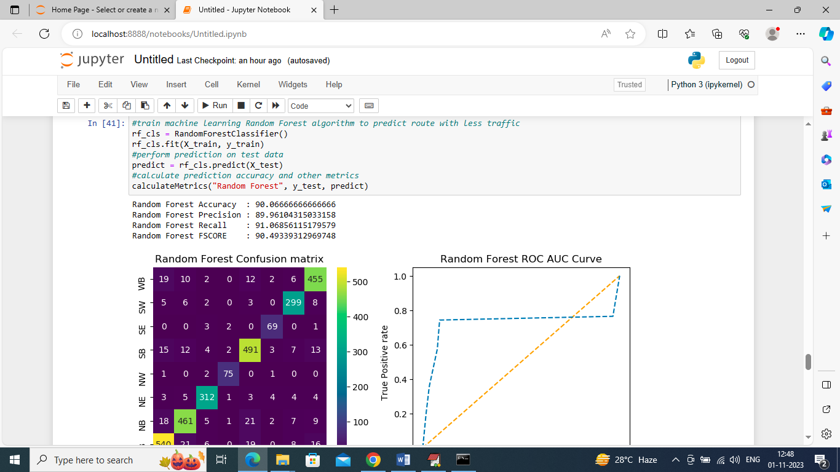

In above screen training Random Forest and it got 90.06% accuracy and can see other metrics also and in above confusion matrix graph in diagnol we can see many records are correctly predicted and in all blue boxes only few are incorrectly prediction. In ROC graph also we can see only few predictions are incorrect

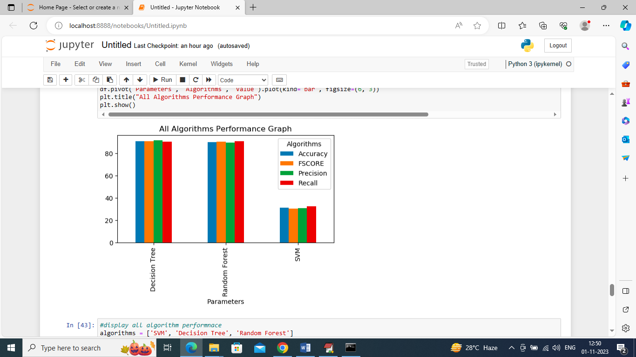

In above graph x-axis represents algorithm names and y-axis represents accuracy and other metrics in different color bars and in all algorithms Random Forest and Decision Tree work best

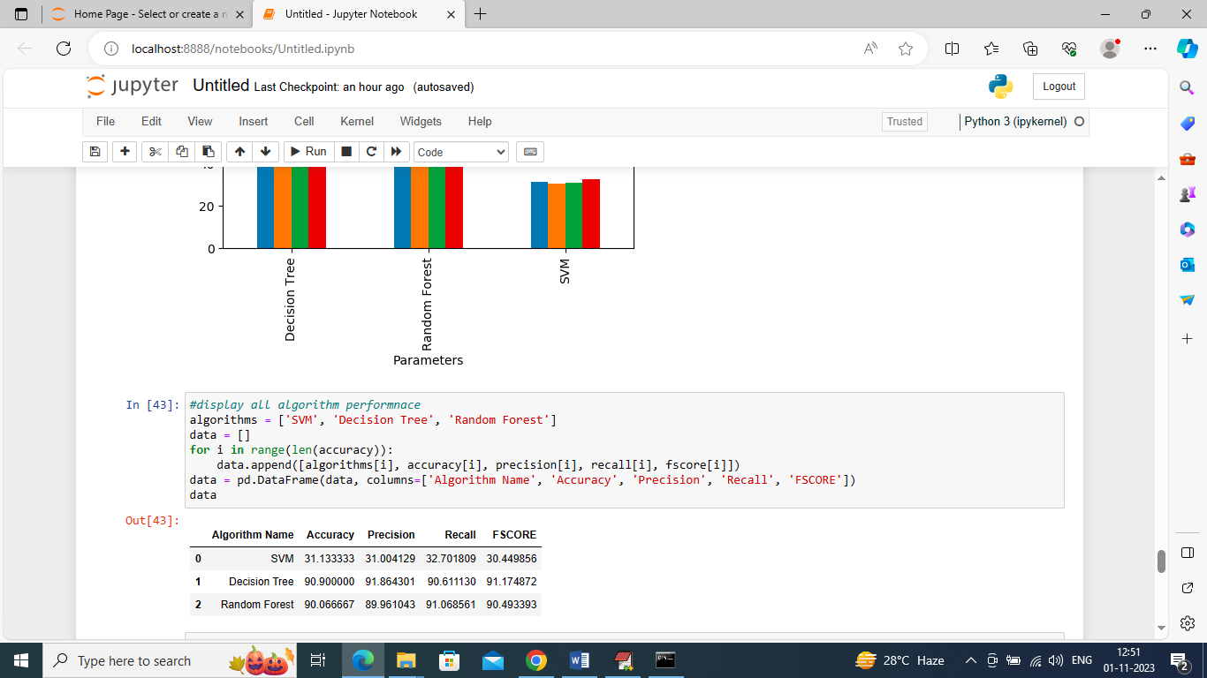

In above screen can see all algorithm performance in tabular format

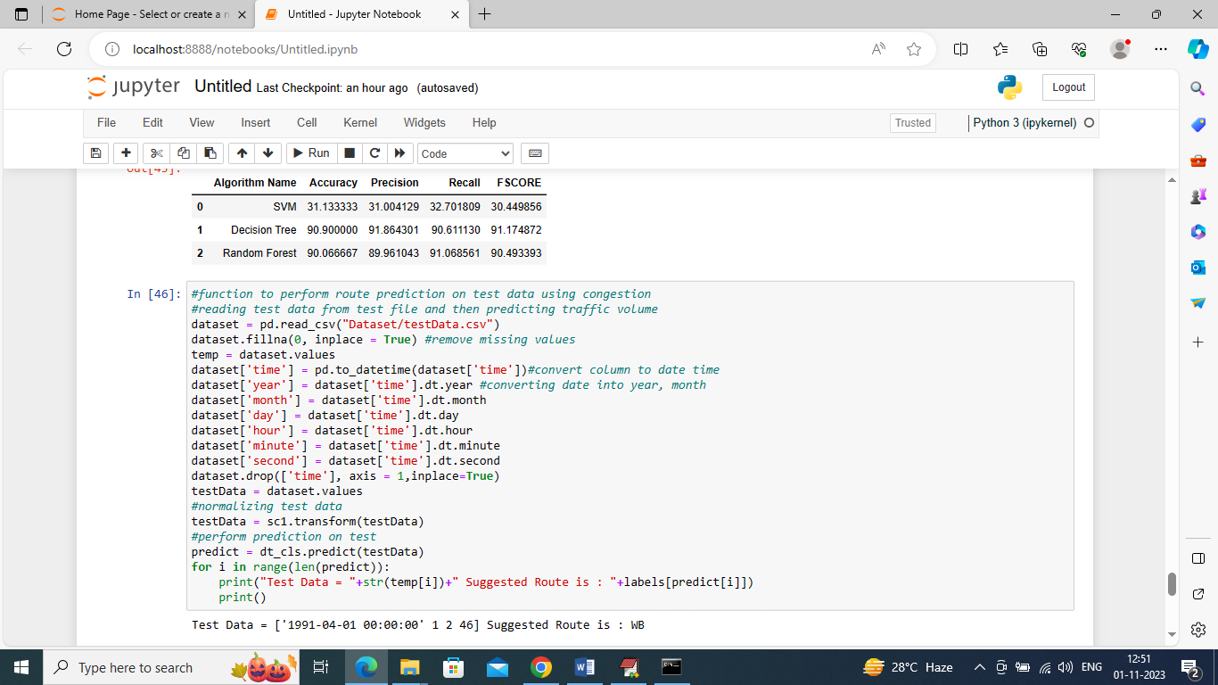

In above screen we are defining function to read TEST data and then perform route prediction on test and after execution above block will get below output

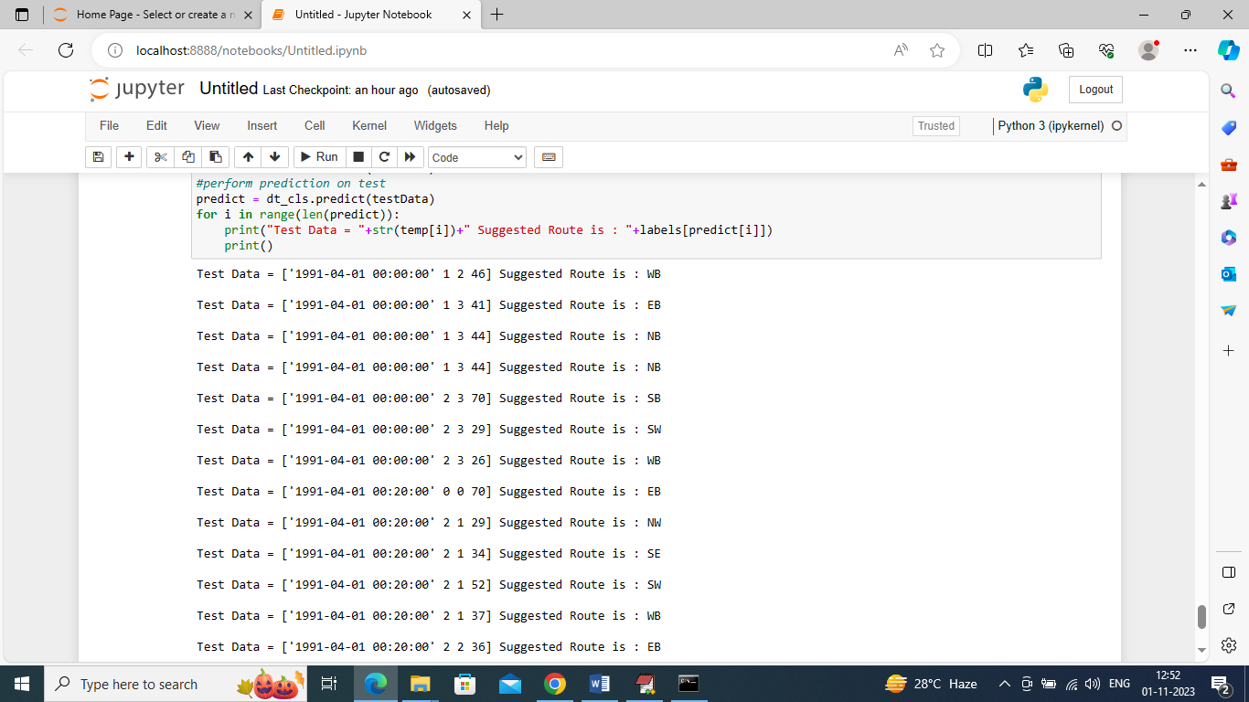

In above predictions in square bracket we can see the TEST data where last value is traffic congestion and based on that congestion we can see suggested Route as WB or NB or SE etc.

Note: the direction of travel of the roadway. EB indicates "eastbound" travel, for example, while SW indicates a "southwest" direction of travel.

**6. CONCLUSION**

In the system, it has been concluded that we develop the traffic flow prediction system by using a machine learning algorithm. The weather conditions have been changing from years to years. The cost of fuel is also playing a major role in the transportation system. Many people are not able to afford the vehicle because of the fuel cost. So, there can be many variations in the traffic data. There is one more scenario where people prefer going on their own vehicle without car pooling, this also matters in the traffic congestion. So, this prediction can help judging the traffic flow by comparing them with these 2 years data sets. The forecasting or the prediction can help people or the users in judging the road traffic easier before hand and even they can decide which way to go using their navigator and also this will prediction will be also helpful.

**7. FUTURE SCOPE**

In the future, the system are often further improved using more factors that affect traffic management using other methods like deep learning, artificial neural network, and even big data. The users can then use this technique to seek out which route would be easiest to achieve on destination. The system can help in suggesting the users with their choice of search and also it can help to find the simplest choice where traffic isn't in any crowded environment. Many forecasting methods have already been applied in road traffic jam forecasting. While there's more scope to create the congestion prediction more precise, there are more methods that give precise and accurate results from the prediction. Also, during this period, the employment of the increased available traffic data by applying the newly developed forecasting models can improve the prediction accuracy. These days, traffic prediction is extremely necessary for pretty much every a part of the state and also worldwide. So, this method of prediction would be helpful in predicting the traffic before and beforehand. For better congestion prediction, the grade and accuracy are prominent in traffic prediction. within the future, the expectation are going to be the estimation of established order accuracy prediction with much easier and user-friendly methods so people would find the prediction model useful and that they won’t be wasting their time and energy to predict the information. There will be some more accessibility like weather outlook, GPS that's the road and accident-prone areas will be highlighted in order that people wouldn't prefer using the paths which aren't safe and simultaneously they'll predict the traffic. This will be done by deep learning, big data, and artificial neural networks.

**REFERENCES:**

1. Vlahogianni, E. I., M. G. Karlaftis, and J. C. Golias. Optimized and Meta-Optimized Neural Networks for Short Term Traffic Flow Prediction: A Genetic Approach. Transportation Research Part C: Emerging Technologies, Vol. 13, No. 3, 2005, pp. 211–234.

2. Machine Learning Approach to Short-Term Traffic Congestion Prediction in a Connected Environment AmrElfar1, Alireza Talebpour2, and Hani S. Mahmassani1, National Academy of Sciences: Transportation Research Board 2018.

3. Big data-driven machine learning-enabled traffic flow prediction Fanhui Kong1 Jian Li1 Bin Jiang2 Tianyuan Zhang3 Houbing Song3, 2018.

4. <https://www.ncbi.nlm.nih.gov/pmc/articles/PMC2845248/>

5. <https://jupyter.org/>

6. Bao G, Zeng Z, Shen Y. Region stability analysis and tracking control of memristive recurrent neural network. Neural Netw. 2017;5(1):74-89.

7. Jiang, X., and H. Adeli.Dynamic Wavelet Neural Network Model for Traffic Flow Forecasting. Journal of Transportation Engineering, Vol. 131, No. 10, 2005, pp. 771–779

8. Identification Traffic Flow Prediction Parameters AnuchitRatanaparadorn Department ofIndustrialEngineering,KasetsartUniversity,Thailand,AnuchitRatanaparadorn,SasivimolMeeampol,ThaneeratSiripachana,Pornthep,Anussornnitisarn, 19-21 2013, zadar, Croatia, international conference

9. YuhanJia, Jianping Wu, and Ming Xu, Traffic Flow Prediction with Rainfall Impact Using a Deep Learning Method,Journal of Advanced Transportation, 2017.

10. Felix Kunde Alexander Hartenstein Stephan Pieper Petra Sauer, Traffic prediction using a Deep Learning paradigm, CEUR-WS.org, 2017